TNE20003 – Internet and Cybersecurity for Engineering Applications

Portfolio Task – Lab 2 Credit Task

Aims:
- To subnet a network according to the given class address and network diagram

- Achieve successful connectivity from your LAN_PC to your LAN network router.

Preparation:
  - View “IP Subnetting"
  - & “IP address and subnetting task-1”
  - & “Network Addressing & Subnetting”
  - Using Self-Directed learning find out about default gateways
    - Where are they placed
    - What is their purpose

Task Completion
- Upon completion of this task you are required to sit the online assessment relating to this lab under the “Quizzes” tab in Canvas. You will be awarded the grade if and only if you meet the requirements. If you do not meet the requirement you will be required to sit the online test for the lower grade. For example if you did the test for a D and did not get the 80% on the 2 attempts then you may take the test for a C.

Due Date:
- IT is advised that you complete the test at the end of the lab. If you do not then the absolute deadline is before the beginning of the lab in the following week.
.

Task 1.

Subnet and Address a Network According to Provided Requirements
In this task, you will
- Undertake the subnetting needed for the network shown in the diagram below and provide Addressing for each network/subnetwork in that diagram.

Instructions
- Using the examples provided in the documents under the tutorial section under modules on Canvas for this unit, carry out the relevant subnetting to completely address the network shown below.

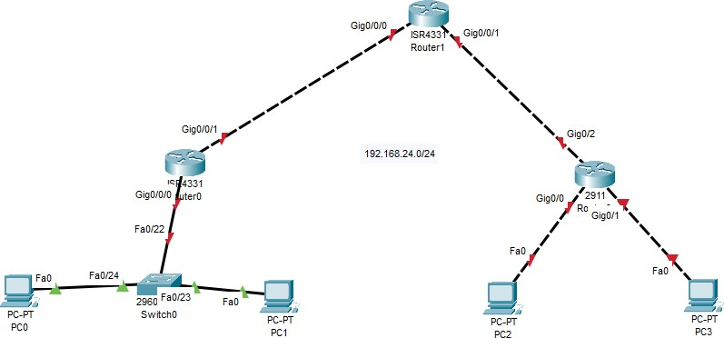
128.100.100.0/25

Figure 1

Some things you may want to consider are:

  - What class of network is the given address?
The address 128.100.100.0/25 is a Class B network.

  - How many networks do I have in the diagram?
  - There are 5 network this diagram.
  - Network 1: Router 0, Switch 0, PC0, PC1
  - Network 2: Router 1
  - Network 3: Router 2
  - Network 4: PC2
  - Network 5: PC3

  - How many host addresses do I need per network/subnetwork?
There are 14 host address that I need per network.

  - WORKING OUT

There are 5 networks:
32-28=4
2^4=16-2(first and last usable) =14hosts addresses.

Task 2.
- For the network given in figure 2 you must build and implement it on Packet Tracer (PT). If needed use the instructions provided in the pass task of lab 2 to name and address the devices.

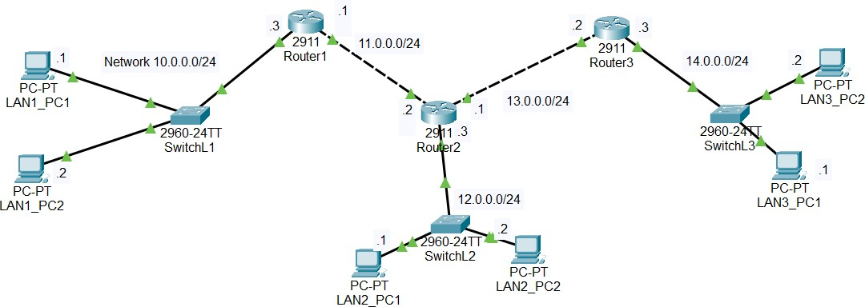

Figure 2

Instructions:

Carry out some basic connectivity tests.
  - Click on Lan1_PC1 and choose “desktop” and then click on the “command prompt”
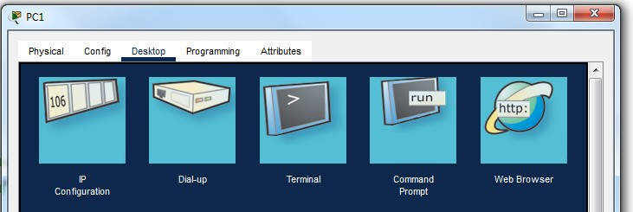

  - In the “command prompt” window type “ping 10.0.0.3”
  - Note what is displayed. Did the ping work?

The ping is successfully working and receiving four replies from 10.0.0.3.
  - In the “command prompt” window type “ping 10.0.0.2”

  - Note what is displayed. Did the ping work?
The ping is successfully working and receiving four replies from 10.0.0.2.

  - In the “command prompt” window type “ping 11.0.0.1”
  - Note what is displayed. Did the ping work?
The ping is not working and shown that request time out.

Communicating to 11.0.0.1
  - From task 1 above you should remember that you were not able to ping 11.0.0.1 from either LAN1_PC1 or LAN1_PC2, but you were able to ping 10.0.0.3.
  - On Router1 issue the following command to enable you to see the ICMP traffic that is sent when you generate a ping or traceroute. Click on Router1 and choose CLI tab at the top. Press enter, then follow the commands in the graphic below:
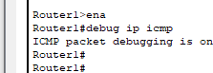
Note that to move from the viewer mode (Router1>) to the enable mode (Router1#) you need to type the word enable.
  - Go to LAN1_PC1 and enter the following command ping 10.0.0.3 -n 10. This will send 10 ping packets to that n/w address. Then click on Router1 and look at the CLI screen. What do you see???
The CLM screen on router 12 shown that “ICMP: echo reply sent, src 10.0.0.3, dst 10.0.0.1” for 10 times.

  - This output shows that the ping packets are being sent by the PC and are arriving at Router1. In Router1 hit enter a few times to enable you to separate the actions of the previous activity with the next one.
  - Now go back to LAN1_PC1 and enter the following command ping 11.0.0.1 -n 10. This will send 10 ping packets to that n/w address. Then click on Router1 and look at the screen. What do you see???

The router 1 display nothing after I ping 11.0.0.1 -n 10 from LAN1_PC1.
  - What is different between steps c) and e) that might explain the different outcomes???
The difference between steps c and e:\
Step c: the destination ip of 10.0.0.3 is within router 1 network.
Step e: the destination ip of 11.0.0.1 is in the different router 1 network, so the packet could not deliver.

- You will need to investigate the reason for this outcome and troubleshoot it to find the solution and then implement the solution at each of the PCs on the 3 LANs.

The issue is that 11.0.0.1 is on a different network, and the PCs need a default gateway set up to communicate with it.

~~~~~ End of Lab ~~~~~

